Indian Institute of Information Technology Bhagalpur
(An Institute of National Importance Under Act of Parliament)



Microprocessor & Interfacings Lab Report

Submitted By : Akhilesh Sumar Singh
Roll No: 2101248CS
Class : Btech 2nd Year
Semester : IV

2nd Year
Semester : IV

Department of Electronics & Communication Engineering IIIT BHAGALPUR,
BIHAR 813210, INDIA

CERTIFICATE
IIIT Bhagalpur

This is to certify that Mr. Akhilesh Kumar Singh bearing Institute Roll No. 2101248cs has satisfactorily completed the course in Microprocessor & interfacings (EC208) during the academic year 2022-2023.

Date: 31/03/2022 Place: IIIT,Bhagalpur

IIIT Bhagalpur
IIIT Bhagalpur

Lab Report: 1

AIM:
Write 8051 assembly code to move 8 bit hexadecimal data XXH(assuming last two digits of roll number) to register R0,R1,R2 ,R3 of the register bank 0.

CODE:
ORG 00H
MOV A,#51H;
MOV R0,A;
MOV R1,A;
MOV R2,A;
MOV R3,A;
END

HEX CODE:
:060000003221F8622FA2B4F
:00000003F5

SIMULATED OUTPUT:
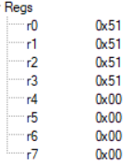

CONCLUSION:
The code initializes the program counter to address 00H, which is the start of the program memory. Then, it moves the immediate value 51H (hexadecimal equivalent of 81 in decimal) into the accumulator register A.
Next, it moves the value of accumulator register A to all four general purpose registers R0, R1, R2, and R3.

Lab Report :2

AIM:
Write 8 bit assembly code to copy 8-bit hexadecimal (30H) to internal locations 30H,31H,32H
CODE:
ORG 00H
MOV 30H, #30H
MOV 30H, #31H
MOV 30H, #32H
END

HEX CODE:
:060000007451F8F9FA25B48
:09000000753030753031767303276
:00000007FF

SIMULATED OUTPUT:
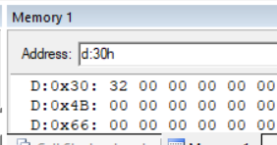
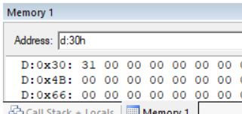
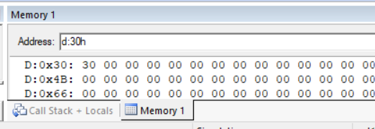

CONCLUSION:
"MOV 30H, #30H", "MOV 30H, #31H", and "MOV 30H, #32H" move the values 30H, 31H, and 32H (which are hexadecimal values representing 48, 49, and 50 in decimal) into the memory location 30H.

Lab Report 3

AIM:
write an 8051-assembly code to copy a 8-bit hexadecimal data, the data is 30 h to internal location 30h, 31h, 32h.
CODE:
ORG 00H
MOV 30H, #30H
MOV 31H, #30H
MOV 32H, #30H
END

HEX CODE:
:060000007451F8F9FAFB4F
:0900000075303075303175303275
:0900000075303075313075323075
:080000007530F0E530F4F53134
:10000000E5305531F532E5304531F533E5306531D0
:02001000F534C5
:10000000E5302532F534E5333531F535F536F5375C
:0F000000749775F00A84A8F075F00A84A9F0FAD5
:090000007400790A2419D9FCFAF4
:0E0000007437F5901109F480F97BC8DBFE22FD
:0E0000007455F540F541F542F543F544F545DC
:0F00000074557840F608F608F608F608F608F684
:0A000000745578407A06F608DAFC21
:00000001FF

SIMULATED OUTPUT:
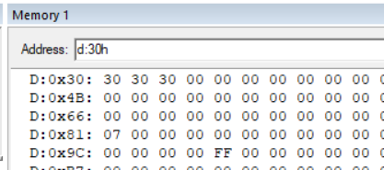

CONCLUSION:
sets the value 30H (which is equivalent to decimal 48) to memory locations 30H, 31H, and 32H, respectively. The program starts by moving the value 30H into memory location 30H using the MOV instruction. It then moves the same value into memory locations 31H and 32H using two more MOV instructions.

Lab Report 4

AIM:
write an 8051-assembly code to copy a 8-bit hexadecimal data, the data is 30 h to internal location 30h, 31h, 32h.
CODE:
ORG 00H
MOV 30H, #0F0H
MOV A, 30H
CPL A
MOV 31H, A
END

HEX CODE:
:060000007451F8F9FAFB4F
:0900000075303075303175303275
:0900000075303075313075323075
:080000007530F0E530F4F53134
:10000000E5305531F532E5304531F533E5306531D0
:02001000F534C5
:10000000E5302532F534E5333531F535F536F5375C
:0F000000749775F00A84A8F075F00A84A9F0FAD5
:090000007400790A2419D9FCFAF4
:0E0000007437F5901109F480F97BC8DBFE22FD
:0E0000007455F540F541F542F543F544F545DC
:0F00000074557840F608F608F608F608F608F684
:0A000000745578407A06F608DAFC21
:00000001FF

SIMULATED OUTPUT:
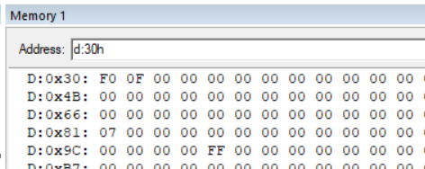

CONCLUSION:
Move the value 0F0H into memory location 30H.
Move the value in memory location 30H into the accumulator (register A).
Complement the value in the accumulator (invert all bits).
Move the complemented value in the accumulator to memory location 31H.

Lab Report 5

AIM:
Write a program to copy a value 55H into RAM memory location 40H to 45H
a- direct addressing mode
b- register indirect addressing mode without a loop.
c- register indirect addressing mode with a loop.
CODE:
A
ORG 00H
MOV A, #55H
MOV 40H, A
MOV 41H, A
MOV 42H, A
MOV 43H, A
MOV 44H, A
MOV 45H, A
END

B
ORG 00H
MOV A, #55H
MOV R0, #40H
MOV @R0, A
INC R0
MOV @R0, A
INC R0
MOV @R0, A
INC R0
MOV @R0, A
INC R0
MOV @R0, A
INC R0
MOV @R0, A
END

C
ORG 00H
MOV A, #55H
MOV R0, #40H
MOV R2, #06H
VARIABLE:MOV @R0, A
INC R0
DJNZ R2, VARIABLE
END

HEX CODE:
A
:060000007451F8F9FAFB4F
:0900000075303075303175303275
:0900000075303075313075323075
:080000007530F0E530F4F53134
:10000000E5305531F532E5304531F533E5306531D0
:02001000F534C5
:10000000E5302532F534E5333531F535F536F5375C
:0F000000749775F00A84A8F075F00A84A9F0FAD5
:090000007400790A2419D9FCFAF4
:0E0000007437F5901109F480F97BC8DBFE22FD
:0E0000007455F540F541F542F543F544F545DC
:0F00000074557840F608F608F608F608F608F684
:0A000000745578407A06F608DAFC21
:00000001FF
B
:060000007451F8F9FAFB4F
:0900000075303075303175303275
:0900000075303075313075323075
:080000007530F0E530F4F53134
:10000000E5305531F532E5304531F533E5306531D0
:02001000F534C5
:10000000E5302532F534E5333531F535F536F5375C
:0F000000749775F00A84A8F075F00A84A9F0FAD5
:090000007400790A2419D9FCFAF4
:0E0000007437F5901109F480F97BC8DBFE22FD
:0E0000007455F540F541F542F543F544F545DC
:0F00000074557840F608F608F608F608F608F684
:0A000000745578407A06F608DAFC21
:00000001FF
C
:060000007451F8F9FAFB4F
:0900000075303075303175303275
:0900000075303075313075323075
:080000007530F0E530F4F53134
:10000000E5305531F532E5304531F533E5306531D0
:02001000F534C5
:10000000E5302532F534E5333531F535F536F5375C
:0F000000749775F00A84A8F075F00A84A9F0FAD5
:090000007400790A2419D9FCFAF4
:0E0000007437F5901109F480F97BC8DBFE22FD
:0E0000007455F540F541F542F543F544F545DC
:0F00000074557840F608F608F608F608F608F684
:0A000000745578407A06F608DAFC21
:00000001FF

SIMULATED OUTPUT:
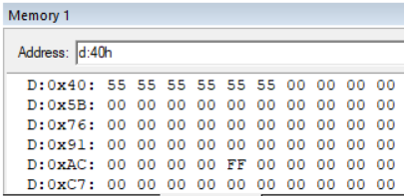

CONCLUSION:
- In direct addressing mode the value (55H) is set into accumulator A and is individually copied to the destinations 40H,41H,42H,43H,44H,45H directly.
- In indirect addressing mode without a loop the value (55H) is set into the accumulator A and the register is initialized with the destination 40H and is incremented by 1 each time the value is copied into it indirectly.
- In indirect addressing mode with a loop the value (55H) is stored into the accumulator A and a register is initialized with the first destination address (40H)
and another register in initialized with the count of running the loop to increment the destination register values using INC. The count is decremented till the final value is reached (45H) using DJNZ.

Lab Report 6

AIM:
Write an Assembly Program to find AND,OR,XOR of data at internal RAM locations 30H,31H and store on the locations 32H,33H and 34H respectively.

CODE:
ORG 0H
MOV 30H, #56H
MOV 31H, #13H
MOV A, 30H
ANL A, 31H
MOV 32H, A
MOV A, 30H
ORL A, 31H
MOV 33H, A
MOV A, 30H
XRL A, 31H
MOV 34H, A
END

HEX CODE:
:060000007451F8F9FAFB4F
:0900000075303075303175303275
:0900000075303075313075323075
:080000007530F0E530F4F53134
:10000000E5305531F532E5304531F533E5306531D0
:02001000F534C5
:10000000E5302532F534E5333531F535F536F5375C
:0F000000749775F00A84A8F075F00A84A9F0FAD5
:090000007400790A2419D9FCFAF4
:0E0000007437F5901109F480F97BC8DBFE22FD
:0E0000007455F540F541F542F543F544F545DC
:0F00000074557840F608F608F608F608F608F684
:0A000000745578407A06F608DAFC21
:00000001FF

SIMULATED OUTPUT:
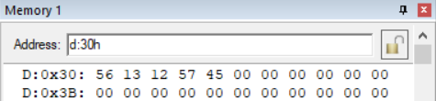

CONCLUSION:
The first two instructions move the values 56H and 13H into memory locations 30H and 31H, respectively.

The next three instructions perform logical operations on the values stored in memory locations 30H and 31H. The ANL instruction performs a bitwise AND operation, the ORL instruction performs a bitwise OR operation, and the XRL instruction performs a bitwise XOR operation. The results of these operations are stored in memory locations 32H, 33H, and 34H, respectively.
Lab Report 7

AIM:
we must add two 16-bit numbers, for operand 1 lower byte and higher byte is stored in 30h and 31h respectively for operand 2 lower byte and higher byte is stored in 32h and 33h and we have to store the result in 35h, 36h and 37h.

CODE:
ORG 00H
MOV 30H, #1AH
MOV 31H, #04H
MOV 32H, #5CH
MOV 33H, #2BH
MOV A, 31H ; move the higher byte of operand1 to accumulator
ADD A, 33H ; add the higher byte of operand2 to accumulator
MOV R7, A ; store the result in R7

MOV A, 30H ; move the lower byte of operand1 to accumulator
ADD A, 32H ; add the lower byte of operand2 to accumulator
MOV R6, A ; store the result in R6

MOV A, 0 ; clear the accumulator
ADD A, R6 ; add the lower byte result to accumulator
MOV 35h, A ; store the lower byte of result

MOV A, R7 ; move the higher byte result to accumulator
ADDC A, 0 ; add the carry bit to accumulator
MOV 36H, A ; store the middle byte of result

MOV A, R7 ; move the higher byte result to accumulator
MOV 37H, A ; store the higher byte of result
END

HEX CODE:
:060000007451F8F9FAFB4F
:0900000075303075303175303275
:0900000075303075313075323075
:080000007530F0E530F4F53134
:10000000E5305531F532E5304531F533E5306531D0
:02001000F534C5
:10000000E5302532F534E5333531F535F536F5375C
:0F000000749775F00A84A8F075F00A84A9F0FAD5
:090000007400790A2419D9FCFAF4
:0E0000007437F5901109F480F97BC8DBFE22FD
:0E0000007455F540F541F542F543F544F545DC
:0F00000074557840F608F608F608F608F608F684
:0A000000745578407A06F608DAFC21
:00000001FF

SIMULATED OUTPUT:
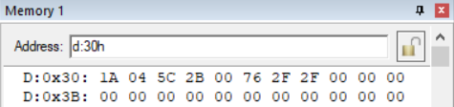

CONCLUSION:
Moves the higher byte of operand 1 from memory location 31H to accumulator A. Add the higher byte of operand 2 from memory location 33H to A. Move the result from A to register R2. Move the lower byte of operand 1 from memory location 30H to accumulator A. Add the lower byte of operand 2 from memory location 32H to A with carry. Move the result from A to register R1. Move the higher byte of the result from R2 to accumulator A. Store the result in memory location 37H.Move the lower byte of the result from R1 to accumulator A.
Store the result in memory location 35H.Add the carry flag to A to get the final carry from the addition of the higher bytes. Store the final carry in memory location 36H.

Lab Report 8
AIM:
Write a 8052 program to convert hexadecimal 97h to decimal value and then store it in R0, R1 and R2.

CODE:
ORG 00H
MOV A, #97H
MOV B, #0AH
DIV AB
MOV R0, B
MOV B, #0AH
DIV AB
MOV R1, B
MOV R2, A
END

HEX CODE:
:060000007451F8F9FAFB4F
:0900000075303075303175303275
:0900000075303075313075323075
:080000007530F0E530F4F53134
:10000000E5305531F532E5304531F533E5306531D0
:02001000F534C5
:10000000E5302532F534E5333531F535F536F5375C
:0F000000749775F00A84A8F075F00A84A9F0FAD5
:090000007400790A2419D9FCFAF4
:0E0000007437F5901109F480F97BC8DBFE22FD
:0E0000007455F540F541F542F543F544F545DC
:0F00000074557840F608F608F608F608F608F684
:0A000000745578407A06F608DAFC21
:00000001FF

SIMULATED OUTPUT:
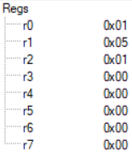

CONCLUSION:
performs integer division of the hexadecimal value 97H by the decimal value 10, and store the quotient and remainder in registers R0 and R1, respectively. The quotient is calculated by dividing the contents of A by the contents of B twice, with the remainder being discarded after the first division. The remainder of the second division is the desired quotient. The value in A at the end of the code is the final remainder.
Lab Report 9

AIM:
Write an 8051-assembly program to multiply 25 by 10 using loop.

CODE:
ORG 00H
MOV A, #00H //CONFIRMING 0 IN ACCUMULATOR
MOV R1, #10
LABLE1: ADD A, #25 //Created a label named LABEL1.
DJNZ R1, LABEL1
MOV R2, A
END

HEX CODE:
:060000007451F8F9FAFB4F
:0900000075303075303175303275
:0900000075303075313075323075
:080000007530F0E530F4F53134
:10000000E5305531F532E5304531F533E5306531D0
:02001000F534C5
:10000000E5302532F534E5333531F535F536F5375C
:0F000000749775F00A84A8F075F00A84A9F0FAD5
:090000007400790A2419D9FCFAF4
:0E0000007437F5901109F480F97BC8DBFE22FD
:0E0000007455F540F541F542F543F544F545DC
:0F00000074557840F608F608F608F608F608F684
:0A000000745578407A06F608DAFC21
:00000001FF

SIMULATED OUTPUT:
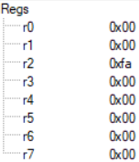

CONCLUSION:
code initializes the accumulator register (A) and register R1 to the values 0 and 10 respectively, and then enters a loop labeled "LABEL1".In each iteration of the loop, the value 25 is added to the accumulator (A), and the register R1 is decremented by 1 using the "DJNZ" (Decrement and Jump if Not Zero) instruction. This continues until R1 becomes 0. Once the loop completes, the final value of the accumulator (A) is moved to register R2, and the program ends. Overall, this program performs a loop that adds 25 to the accumulator 10 times, resulting in a final value of 250 in register R2.

Lab Report 10
AIM:
find the size of the delay in the following program if the crystal frequency is 11.0592MHz.

CODE:
ORG 00H
ORG 00H
MOV A, #55
AGAIN: MOV P1, A
ACALL DELAY
CPL A
SJMP AGAIN
DELAY: MOV R3, #200
HERE: DJNZ R3, HERE
RET
END

HEX CODE:
:060000007451F8F9FAFB4F
:0900000075303075303175303275
:0900000075303075313075323075
:080000007530F0E530F4F53134
:10000000E5305531F532E5304531F533E5306531D0
:02001000F534C5
:10000000E5302532F534E5333531F535F536F5375C
:0F000000749775F00A84A8F075F00A84A9F0FAD5
:090000007400790A2419D9FCFAF4
:0E0000007437F5901109F480F97BC8DBFE22FD
:0E0000007455F540F541F542F543F544F545DC
:0F00000074557840F608F608F608F608F608F684
:0A000000745578407A06F608DAFC21
:00000001FF

SIMULATED OUTPUT:
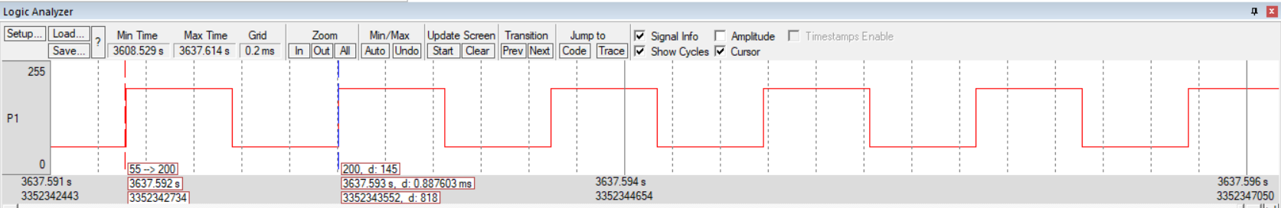

CONCLUSION:
This is a simple assembly language code for an 8051 microcontroller that creates a blinking pattern on an LED connected to Port 1 (P1) of the microcontroller. The next instruction is MOV A, #55, which moves the hexadecimal value 55 into the accumulator register A.
The label AGAIN is then defined, followed by the instruction MOV P1, A, which moves the value of A into the P1 port. This turns on the LED connected to the P1 port.
The ACALL DELAY instruction calls a subroutine named DELAY, which creates a delay between the LED turning on and off. The CPL A instruction complements the value in the A register, which effectively toggles the LED state from on to off and vice versa.
The SJMP AGAIN instruction jumps back to the AGAIN label, restarting the loop and causing the LED to blink. The DELAY subroutine starts with the instruction MOV R3, #200, which moves the value 200 into the R3 register. This register will be used as a counter to create a delay. The label HERE is defined next, followed by the DJNZ R3, HERE instruction. This instruction decrements the value in the R3 register and jumps back to the HERE label as long as the R3 register is not zero. This creates a delay of approximately 200 x 3 clock cycles.
Finally, the RET instruction returns to the main program after the delay subroutine is complete.

The DELAY can be calculated as the time between 2 wave pulses which can be done by subtracting the start point of simultaneous wave pulse as shown in the above fig.

